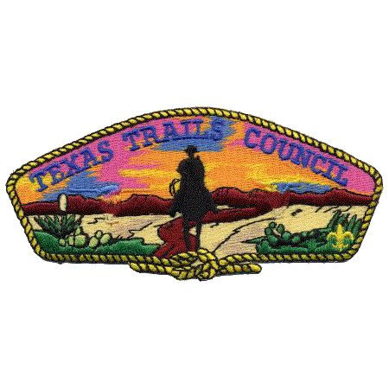

TEXAS TRAILS COUNCIL
BOY SCOUTS OF AMERICA
Cub Scout Resident Camp
ADVENTURE GUIDEBOOK

CAMP TONKAWA
Webelos Resident - JUNE 17 - 21, 2018
Cub Scout Resident - JUNE 24 - 28, 2018

Texas Trails Council
Boy Scout Service Center
3811 N. 1st St.

Abilene, Texas 79603
(325) 677-2688
www.texastrailsbsa.com

TABLE OF CONTENTS

LETTER FROM THE CAMP DIRECTOR 3
PLANNING YOUR WEBELOS CAMP ADVENTURE 4
REGISTRATION REQUIREMENTS 5
MEDICAL TREATMENT NOTES 7
CAMP SERVICES 9
RULES AND REGULATIONS AT CAMP 12
UNIT RESPONSIBILITIES 16
CHECK-IN AT CAMP 18
CHECKING OUT OF CAMP 18
MAP TO CAMP TONKAWA 19

LETTER FROM THE CAMP DIRECTOR

Hello leaders and parents,

We are planning an exciting and innovative summer camping season at Camp Tonkawa. This summer for the first time we will have one week of Webelos resident camp and one week of Cub Scout Family Resident Camp.
- Webelos are encouraged to attend either session
- Tiger through Bear may only attend the June 24-28 session
- Leader ratio of 2 adults for every 8 youth are required
- Maximum Den Size of 12 scouts
- Packs may require parents and guardians to attend with their Tiger - Bear Scout
We here at the Texas Trails Council are excited to offer this new program for ALL Cub Scouts and look forward to an amazing summer adventure like no other.

Sincerely,
Jaime S. Limas
Camp Director

PLANNING YOUR SUMMER

CAMP ADVENTURE
Planning for camp should start several months before your unit plans to arrive at camp. As a Den Leader, it is your responsibility to insure your Scouts are prepared to set and accomplish their personal goals. Here are a few basic tips to help you insure this happens.
- You should take a few minutes at a Pack meeting to talk with each Scout individually about the summer camp agenda and provide guidance on individual preparation.
- Some Packs find it helpful to hold a “Summer Camp Meeting” just prior to camp to go over what Scouts need to bring with them for the camp session. At this meeting you should also hand out information packets to parents, finalize paperwork, secure the needed equipment for the Pack campsite, and review the program schedule.
- Most of all, remember that Webelos camp is an opportunity for Scouts to grow both mentally and physically. The older Scouts should assist as much as possible in preparing the younger Scouts for camp.

GETTING BOYS EXCITED ABOUT CAMP!!!
This can be accomplished in many ways. Several ideas for promotion include:

- Take your Scouts to Camp Tonkawa during the "off season", and let them explore. Discuss the different program areas and historical sites around camp.
- Hold Pack fund raising projects to help Scouts earn part of their own camp fees.
- Show slides or videos of previous summer camps at Pack meetings.
- Invite former and current staff members to visit your Pack to talk about camp to heighten the Scout’s interest.
- While on a Pack campout, have a campfire and share songs, stories and skits from previous summer camp experiences.

INFORMING PARENTS ABOUT CAMP
Successful Packs hold an informational meeting for parents before camp. This meeting can be held in conjunction with a Pack meeting, or at some other convenient time prior to summer camp. Parents need to be informed about all the details regarding summer camp. Visitor’s night information, camp rules, equipment needs, and departure and arrival times should all be covered during this meeting. All the needed information for a pre-camp meeting can be found in this Webelos Leader Guidebook.
REGISTRATION REQUIREMENTS
The Texas Trails Council, Boy Scouts of America provides program, facilities, and services without regard to race, color, national origin, age, gender, or handicap. However, all leaders and youth on the camp must be current registered members of the Boy Scouts of America. All part-time leaders that will be camping overnight on the camp must be current registered members of the Boy Scouts of America. Also, no camper, youth or adult, will be permitted to stay in camp unless their full camp fees have been paid prior to the start of their camp session.

2018 CAMPING SEASON FEES
 | On or Before May 25, 2018 | After May 25, 2018
Youth | $125.00 | $175.00
Leaders | $80.00 | $100.00
Part-Time Leaders (Part time leaders are leaders spending less than ½ time at camp | $30.00 per day | $40.00 per day

- There are no part-time youths at camp. All youth pay the full fee.
- A Late Fee of $50.00 will be applied to all reservations received after May 25, 2018 or reserved slots that are not paid in full by May 25, 2018. The only exception to this policy will be for Scouts and Webelos Leaders joining Scouting for the first time on or after May 25, 2018. Any unit adding a Scout or Webelos Leader after this date must give the Council Office a specific name. This policy is intended to assist us in planning our food, supplies, and equipment orders in advance of your arrival.
- If a unit discovers that a Scout or Webelos Leader cannot attend summer camp, and alerts the Scout Center on or before May 25, 2018, $50.00 of that person's camp fee will be non-refundable. Scout and full-time leadership slots are interchangeable.

REFUND POLICY
Packs are asked not to over reserve places for Scouts and leaders. This often means that others will be denied spaces, which would have otherwise been available. There are no refunds for “no shows”. Only medical emergencies will constitute a valid reason for a refund. $50 is not refundable in any case. The Council will credit refunds to the Pack’s Unit Account at the Council Service Center for use by the Pack for Scout Shop purchases, registrations and Boy’s Life fees, or event, activity and training fees.
If a Scout or leader becomes ill while attending camp and is sent home by the camp medical staff, they are eligible for a pro-rated refund (by day) of the “balance of fee.” (Remember $50 is non-refundable.) If a camper leaves without being sent home by the camp medical staff, there is NO refund.
All refunds and overpayments will be processed after camp has been balanced by the Council Service Center. All refunds and overpayments will post to the Pack’s Unit Account at the Council Service Center. A notification of the deposit will be mailed to the Pack Committee Chairman.

CAMPERSHIPS & FINANCIAL NEED
Financial aid is available to help Scouts and families in need of financial assistance. Campership Application forms are available at the Texas Trails Council office and in this packet. Financial aid is not designed to pay the entire camp fee for the Scout. The family, pack, and/or chartering institution should pool their resources first with a financial aid request designed to meet the balance required. Remember, every Scout should be able to attend camp regardless of his personal financial circumstances. Thank you notes from those who receive aid are appreciated.

CAMP PACK LEADER & FULL/PART TIME LEADERSHIP
The person in charge of your Pack must be at least 21 years of age. There are no exceptions. In addition, it is the policy of the Boy Scouts of America that outings may never be led by only one adult. Everyone MUST have face to face youth protection. The result is more fun for the adults and a better program for the Scout. Preferably, the Pack should be under the leadership of its registered Cubmaster. If the Cubmaster is unable to attend full time, the Pack committee should name a Camp Pack Leader. The Camp Pack Leader should participate in the daily leader’s meeting and assign and coordinate the responsibilities for all the adult leadership at camp for your unit.
Again, all full-time adult leaders attending camp must have paid their full camp fee prior to the start of camp. Part-time adult leaders must check-in at the Camp Office upon arrival at camp, and checkout through the office as they depart. Part-time adult leaders pay on a per day basis. Please reference the chart in Section I for appropriate fees. These payments may be made at camp through the Camp Director

MEDICAL TREATMENT NOTES
PHYSICAL EXAMINATIONS - All Scouts and Webelos Leaders going to camp must, upon arrival, present a completed Part A, B and C medical form, signed by a licensed health-care provider/physician (MD, or DO). See appendix for the forms.
NON-EMERGENCY TRANSPORTATION - Each Pack must provide transportation to and from the Health Lodge and local health facilities in non-emergency situations. If transportation is not available from the Pack, check with the Camp Director or Health Officer for assistance.
PRESCRIPTION MEDICATION – All prescription medication will be kept in the Camp Health Lodge unless it is an Epi-Pen, rescue inhaler or other “immediate need” medication. Also, please note that needles used for insulin injections or other prescribed medications must be placed in the biohazard container located in the health lodge. The Health Lodge will provide cold storage for medications requiring refrigeration.
SPECIAL NEEDS - Any Scout or Webelos Leader with needs that require accommodations while at camp, need to tell us well in advance of those Services of the type of need, i.e. physical, medical, dietary, food allergies, etc. Food allergies and dietary requests should be turned in by May 25th.
UNIT FIRST-AID KITS - Everyone should be familiar with basic first aid. It is important that each Pack be prepared to treat minor cuts, scrapes and abrasions. Bandaged wounds should be kept clean to aid in preventing infection, especially in an outdoor setting. The following is a list of recommended contents for a Pack first aid kit:
One 4” Roll of Bandage | One 2” Roll of Bandage | Two Rolls of 1” Tape
Two Triangular Cravats | Four Elastic Bandages | Antibacterial Soap
One Box of Assorted Band-Aids | Twelve 4x4 Sterile Pads | Scissors
Six Pairs of Latex Gloves | Twelve 2x2 Sterile Pads | Needle and Tweezers
Safety Pins | Sunburn Lotion | Tylenol/Non-Aspirin Tablet
Index Cards | Scotch Tape
USAGE POLICY OF MOTORIZED CARTS - The Health and Safety of all Scouts and Leaders attending is the first priority of our operation while they participate in outdoor programs at our summer camp. From time-to-time, youth members with disabilities may have a challenge with the amount of foot-travel that is required to participate in the programs at camp and are in need of special assistance in the form of a motorized cart while at camp. To protect all Scouts and Leaders while in camp, the following guidelines have been established for the use of motorized vehicles such as golf carts, electric scooters, etc. for transportation of individuals with limited mobility. On the Scout’s Camp Physical, the need for a motorized vehicle must be noted by the signing physician.
- Personal vehicles or carts are not allowed, unless is it designed specifically for a particular scout with a disability. Personal vehicles must be inspected by the Health Lodge prior to being used at the camp so that it can be determined safe to operate on the terrain found at both of our camps. Not all motorized vehicles are designed or are safe in this environment and could put a scout at risk of injury. When a personal vehicle or cart is used, a Certificate of Liability Insurance covering the vehicle must be presented. This Certificate should name the Council as a co-insured.
- The assigned driver of the vehicle shall be over the age of 21 and the youth member shall not operate the vehicle by themselves.
- The vehicle is solely for the purpose of the transporting the Scout with a disability. Additional riders or operating the vehicle for other purposes will not be permitted.
- The camp will not provide vehicles for use.
- Adults may bring their own vehicle to camp if the following criteria are met:
  - Their Camp Physical states that they are in need of this type of assistance.
  - It is inspected by the Health Lodge to determine it appropriate design for the terrain of the reservation (Gators or mules will not be allowed)
  - It is for the sole use of the owner. Additional passenger, drivers or scouts will not be allowed to ride or operate it.
  - Certificate of Liability Insurance which names the Council as a co-insured is presented.

CAMP SERVICES

CAMP OFFICE
The Camp Office is open daily from 8:00 AM to 9:00 PM. The office staff is eager to meet the needs of any leader. The following are important things to know about the office.
- The "Lost and Found" is located here. (In front of the Training Center)
- All Scouts and leaders must check in and out with the office when coming to or leaving camp. See the check in and check out procedures.
- Toilet paper and hand soap for each campsite is available in the camp office.
- Report any emergencies to the office immediately. Office staff will notify the proper personnel.
- Incoming telephone messages are placed in your campsite's mailbox in the office.
- All incoming mail for your unit will be handed out at lunch or evening flags.
- Letters and postcards can be mailed from the office.
- Scouts should be encouraged to stay out of the office except in cases of emergency, unless accompanied by an adult.

CAMP MAIL SERVICE
Mailboxes for each campsite, which should be checked by a leader daily, are located in the Camp Office. Outgoing mail is also delivered to the Post Office from here daily. Letters for Scouts at camp should be sent to the following address:
Scout’s Name & Pack Number
Camp Tonkawa
4117 FM 89
Tuscola, TX 79562

CAMP PHONE SERVICE
The Camp Office telephone is used for camp business and emergencies only. The telephone number is 325-572-3337, and it is answered 24 hours a day, but is for emergencies only.

SWIM CHECKS & POOL ORIENTATION
Following your unit’s Swim Check on your check-in day, each unit will receive a short pool orientation. During swimming pool orientation, Scouts will be shown how to “check in” and will be informed about the rules and regulations that are to be followed during free swims. You will also be given a swim test during the orientation time.

TRADING POST
The Camp Tonkawa Trading Post is stocked with various souvenirs, t-shirts, patches, camping gear, writing materials, stamps, refreshments, and toilet articles. The following hours of operation are subject to change due to staffing and camper traffic. The trading post is open after morning flags until approximately 9:30 pm. The specific hours of the trading post will be announced and posted.
SPENDING MONEY - It is suggested that Scouts bring spending money to camp. We have a very well stocked Trading Post. Some Scouts bring approximately $50 or a prepaid credit card to camp. Packs may wish to operate a "bank" to hold money for Scouts while at camp. Only small bills $1s, $5s & $10s should be brought to camp. The Trading Post cannot easily make change for larger bills. The Trading Post also can process Credit Card payments for purchases over $5.00
All personal items and spending money should be kept in a secure camp box while at camp. Clothing should be clearly marked with your full name and Pack number. Camp Tonkawa is not responsible for securing or for the loss of personal items. It is your responsibility to keep track of all personal valuables while at camp.

CAMP T-SHIRTS
T-shirts are available to order for $12 each for youth and adult sizes up to Large. XL –XXXL are available for $15 each.

HEALTH LODGE
The Health Lodge is located across from the Camp parking lot, and is available for emergency assistance 24 hours a day. Camp medical personnel will assist you with any medical emergency during the session. If they are not in the Health Lodge upon your arrival, their location will be posted on a sign outside the Health Lodge door.

CAMP RELIGIOUS SERVICES
A non-denominational camp vespers service is tentatively scheduled for Wednesday after breakfast. All Scouts and leaders are encouraged to attend vesper services. A Camp Chaplain is always available for counsel to all Scouts.

CAMP UNIT PHOTO
The Webelos Camp Unit photo will be taken on Monday. Copies of the photo are available later in the Session and can be purchased at the Trading Post. All units are encouraged to wear Class “A” uniforms or Pack T-Shirts.

CAMPSITE COMMISSIONERS
Your campsite is the base from which the program at Camp Tonkawa operates. A Campsite Commissioner is assigned to your unit to help it develop and carry out a full and balanced camping program. The degree of assistance rendered by the commissioner will depend upon the needs, desires and experiences of each unit. The primary purpose of their work is to help you help your unit. They will visit your campsite every day to help you with your camp program.
The Campsite Commissioner's function will be similar to that of your Unit Commissioner back home; except they will be available to you during the full time you are in camp. They have a sound understanding of Scouting's basic principles, the Webelos program, and possess most of the traditional Scouting skills. Call upon them for help whenever needed. Program snarls can often be quickly solved with their help, or perhaps you need something "special" for your boys that just don’t appear to be available. Ask your Campsite Commissioner about it, chances are they will know right where to go.

VISITOR’S NIGHT
The Visitor's Night campfire will be held on Thursday evening. Visitors are welcome in camp after 3:00 p.m. Dinner for visitors is available and consists of a picnic-style meal served in the Dining Hall with the pack.
The cost is $8.00 per meal for adults and $4.00 per meal for children 2-10 years of age; less than 2 years old are free.
Guests for the family night meal must make paid reservations through their pack leader prior to visitor's night. Reservations must be turned into the Camp Office by breakfast on Tuesday. Packs may invite their guests to bring out dinner to share with the Pack in their campsite instead of eating in the dining hall. Leaders need to make sure that visitors do not bring alcoholic beverages.

RULES AND REGULATIONS AT CAMP

GENERAL SAFETY TIPS
- Always hike in groups of three or more. Webelos need their leader’s permission before going hiking. Note their route and ask them when they plan on returning to the campsite.
- Wear closed-toe shoes at all times to prevent cuts and bruises (no sandals).
- Keep the latrine and campsite areas clean and free from hazards.
- Place trash in waste receptacles and recycle when possible.
- STAY OFF, the rappelling tower and C.O.P.E. course.

VEHICLE USE IN CAMP
The drivers of vehicles on the camp must be at least 18 years of age, and possess a current driver's license. Be sure all cars and buses transporting your boys have adequate insurance. No individuals may be transported in the bed of pick-up trucks!
Boy Scouts of America regulations prohibit using the cargo area of any vehicle including but not limited to SUVs, vans, and trucks (including pick-ups with camper shells) and trailers for the transportation of passengers; persons riding on the tailgates of station wagons is also prohibited. Please cooperate by keeping your Scouts off such equipment.
Each occupant must have and use a seat belt. Scouts should wear their uniforms when traveling to and from camp.
The maximum speed limit for all vehicles at camp is 10 miles per hour. No driving off-road is permitted, and all vehicles must be parked in designated parking areas. No vehicles of any kind are allowed in the campsites. The Texas Trails Council is not responsible for loss or damage caused by fire, storms, theft, or vandalism to any personal vehicles, or for any loss or damage to articles left in said vehicles.

ALCOHOLIC BEVERAGES & NARCOTIC DRUGS
The Texas Trails Council will not tolerate the presence and/or use of alcoholic beverages, narcotics, drugs, or persons obviously under the influence of same, at any of our council camps. Violators will be asked to leave camp immediately. Leaders are expected to set an example for their boys to follow. Please announce to all parents coming to camp as part-time leaders, or visitors, that alcoholic beverages are banned from camp property.

FIREWORKS, FIREARMS AND WEAPONS
Fireworks are not permitted at camp. Fireworks will be confiscated, and destroyed by the local fire marshal, and your unit may be asked to leave camp. Please make sure that your boys do not bring any fireworks to camp.
Personal firearms, archery equipment, and sheath knives are not allowed in any area of camp including the archery and rifle ranges. If brought to camp, these items must be turned into the Camp Director until the unit checks out at the end of the camp session. Experience over the years has taught us that boys and sheath knives are not a wise combination. Please insure that this type of personal equipment is left at home, and not brought to camp by your boys or adult leaders.

FIRE PROTECTION
In case of fire, notify the camp office immediately. Do not attempt to fight any fires yourself!
In addition, ground fires are allowed in the campsites after being approved by the Camp Ranger.

LIQUID FUEL POLICY
The use of liquid or jellied fuels such as gasoline, oil, sterno or kerosene for lighting, cooking, generators, or other motors other than automobiles is prohibited at camp. The storage of any type of liquid fuel in pack campsites is not allowed and strictly prohibited. The council health and safety, risk management, and camping committees have agreed that the storage and/or possession of such fuels constitute a safety hazard to our Scouts at camp. There will be no exceptions to the above policy.

ROPE SWINGS & PIONEERING PROJECTS
Due to their inherent risk, rope swings are prohibited at camp. All monkey bridges and pioneering projects constructed at camp must have the prior approval of Camp Director.

STAFF HOUSING AREA
Scouts and pack leaders are not permitted in camp staff housing areas. Remember that these areas comprise their homes for the entire summer. The staff deserves just as much privacy in their living areas as your pack deserves in its campsite.

PETS
Pets are not allowed at any time on camp property.

DRESS CODE
Class A or Class B for adults and boys (uniform shirts, or Scouting t-shirts and shorts). No tube tops, short shorts, racing Speedos, or two-piece swimsuits. As a reminder, a Scout is morally straight. Dress should be appropriate to the camping experience. Dress should never be in question.

TABLE WAITER
Waiters assist in the clean-up of the dining hall and their tables after meals. Special instructions are given to all waiters at each meal to cover variables.
The clean up after the meal should take only a few minutes. An adult supervisor from your unit would be helpful. If there is spilled food, the waiter responsible will be required to do some spot cleaning as well. We require that there be only one waiter per table per meal, and that they follow directions closely.

SMOKING AND TOBACCO POLICY
THE USE OF ANY FORM OF TOBACCO IS PROHIBITED.

CONSERVATION POLICIES
  - Do not cut down any trees.
  - Only conduct conservation projects that have approval of the Camp Management.
  - Never leave a fire unattended! Make sure to put it "dead out" with water and dirt.
  - Please leave your campsite cleaner than you found it.
  - Please pick-up any trash you find along camp trails.

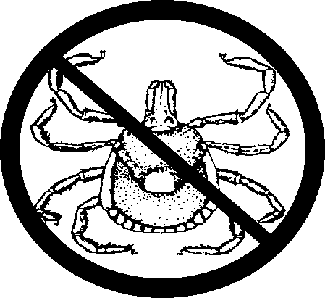
LYME DISEASE
Anyone participating in outdoor activities should take steps to prevent exposure to tick bites. The Department of Health recommends the following when participating in activities in areas where you suspect ticks are present:
- Wear long-sleeved shirts and long pants. Tuck pants into boots or socks.
- Wear light colored clothing to make it easier to spot ticks.
- Conduct frequent and thorough "tick checks". Finding and removing ticks quickly is important.
- Wear insect repellents that help repel ticks.

WILDLIFE
Camp Tonkawa is home to many types of wild animals. Please read and share the camp wildlife plan distributed at check in. Hunting or harming wildlife is not permitted. Only your Camp Nature Staff is authorized to collect and display wild animals. If you have an unwelcome snake or other critter in your campsite, please contact the camp office and steps will be taken to address the situation. In addition, the use of claws, feathers and other parts from birds of prey are prohibited. Remember that federal law protects birds of prey and possession of their parts and is punishable by fine or imprisonment.

EQUIPMENT PROVIDED BY CAMP TONKAWA
All equipment needed for tent camping is provided as part of your camp fee. The equipment you will be assigned, and given to utilize during your stay, will include the following items:
- Campsite Bulletin Board Picnic Table
- Flag Pole
- Latrine & Water Supply
- Campfire Area

EQUIPMENT DAMAGE CHARGES
Each camper and pack is responsible for taking care of the camp equipment assigned for their use. In case of damage to this equipment, the individual or pack is responsible for the cost of repairing or replacing the damaged item.
Damage to equipment furnished by the camp will be evaluated by the Camp Ranger. Charges for destroyed waterproofing and types of damage not noted above will be determined on a case by case basis.

UNIT RESPONSIBILITIES

DRINKING WATER & ICE
Drinking lots of water instead of soda pop is important during hot weather. Scouts should be encouraged to drink at least one gallon of water a day outside of meals. Each program area will have a water cooler for convenience. Packs are encouraged to bring water coolers to camp and keep them filled with ice water. Ice for coolers can be purchased at the camp Trading Post.

SELLING POLICY
The sale of unauthorized merchandise to campers, leaders, or staff for personal or unit profit is not permitted.
The Texas Trails Council, Order of the Arrow, and Penateka Lodge logos are protected, and written permission is required to use them. The Texas Trails Council, BSA, Boy Scouts of America, by signature of the Scout Executive, shall have the sole right to authorize the use of insignia, words, phrases, designation marks, pictorial representation, and descriptive remarks related to the program of the corporation. This includes the Order of the Arrow and Penateka logos, on commercial products, promotional efforts and/or sale and distribution to members of the Boy Scouts of America and/or the general public. The use of same shall be only as authorized and approved by the Scout Executive. 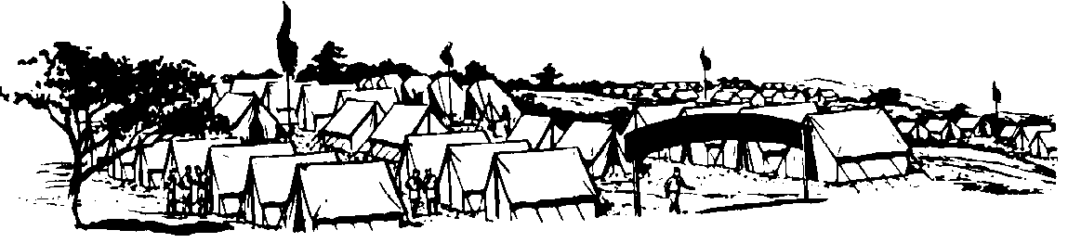

ITEMS YOUR PACK SHOULD PROVIDE FOR YOUR CAMPSITE
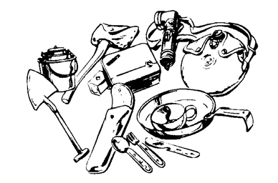
- American & Pack Flag
- Pack First Aid Kit
- Water Containers
- Trash Bags
- Rope & Binding Twine
- Lock Box for Pack Valuables
- Items in Clear Plastic Covers for Campsite Bulletin Board
- Ax, Bow Saw, Rake, and Shovel
- Lanterns (Battery Operated or Propane Only)

WHAT TO BRING TO CAMP
- Health Form (completed and current)
- Official Scout Uniform
- Camp T-shirt (new ones available at trading post)
- Extra shirts, shorts, underwear, Socks, etc.
- Sleep wear
- Jeans or Long Pants
- Swimming Suit (1-piece suit for ladies)
- Sun Block
- Raincoat or Poncho
- Hiking boots & tennis shoes
- Hat or Cap
- Handkerchief
- Bath towels
- Toothbrush & Toothpaste, Shampoo, Soap, Comb
- Sleeping Bag or Blankets, Pillow
- Flashlight & Extra Batteries
- Scout Handbook
- Paper & Writing Utensils
- Mosquito Repellent (Non-Aerosol)
Optional Items:
- Envelopes & Stamps
- Camera & Film
- Sunglasses
- Sewing Kit
- Trash Bags
- Other Items as Needed for Programs

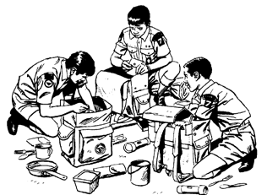

CHECK-IN AT CAMP
Packs should plan to arrive at camp AS A UNIT between 5:30-7:30pm on Sunday evening. Make plans to meet at your Pack meeting location at a specific time, and leave together so you can arrive at camp AS A UNIT.
    - Please note: no-one may enter the camp between the hours of 10:30 p.m. and 6:59 a.m.
Upon arrival at Camp Tonkawa, all units will report to the Training Center. The top unit leader will register the unit as a group. The leader should have with him/her:
  - Verification of participants on the unit roster
  - Sexual Predator report from the Texas Department of Public Safety for each adult
  - Face to face youth protection cards for each adult
The top unit leader, with the Camp Guide, will inspect the campsite assigned to your unit. The unit will change into swim suits and head to the Aquatic area (pool) for swim tests. The unit will then report to the Dining Hall for orientation. The unit will then complete setting up the campsite. The top unit leader will report to the adult leader’s meeting at 6:45 PM.

CHECKING OUT OF CAMP
    - Please note: no-one may enter the camp between the hours of 10:30 p.m. and 6:59 a.m.
Checking out as an individual:
- Report to the Camp Office with the top unit leader, Scout and parent.
- Person taking a Scout from camp must show picture ID. If the person is not a parent or guardian, they must have written authorization from the parent and signed by the parent to transport the Scout.
- Camp Director and unit leader must sign the person out.
Checking out as a unit:
- The camp guide will report to the campsite after supper on Thursday. Please have all the gear ready to move out of the campsite so that the host and top unit leader can inspect all the equipment and facilities for damage incurred during your stay. If your unit is not ready, or plans to check out later, please schedule a time with your host to come back to inspect the campsite.
- If your unit plans to use your campsite after check-out please let the camp guide know when you are going to leave camp.
- Take the inspection form to the office for check out.
  - Fee payment for damages in campsite
  - Receive your check out packet (health forms, patches, etc.)
  - Turn in your camp evaluation form
- Pick up any medication stored at the Health Lodge.

HAVE A SAFE TRIP HOME!

MAP TO CAMP TONKAWA

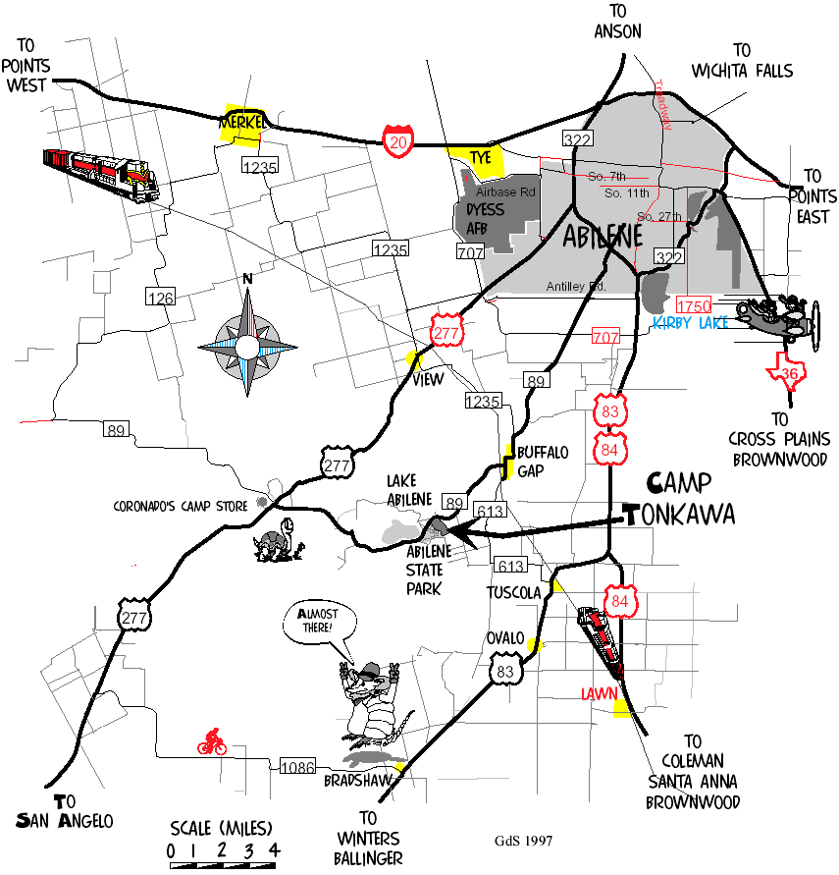

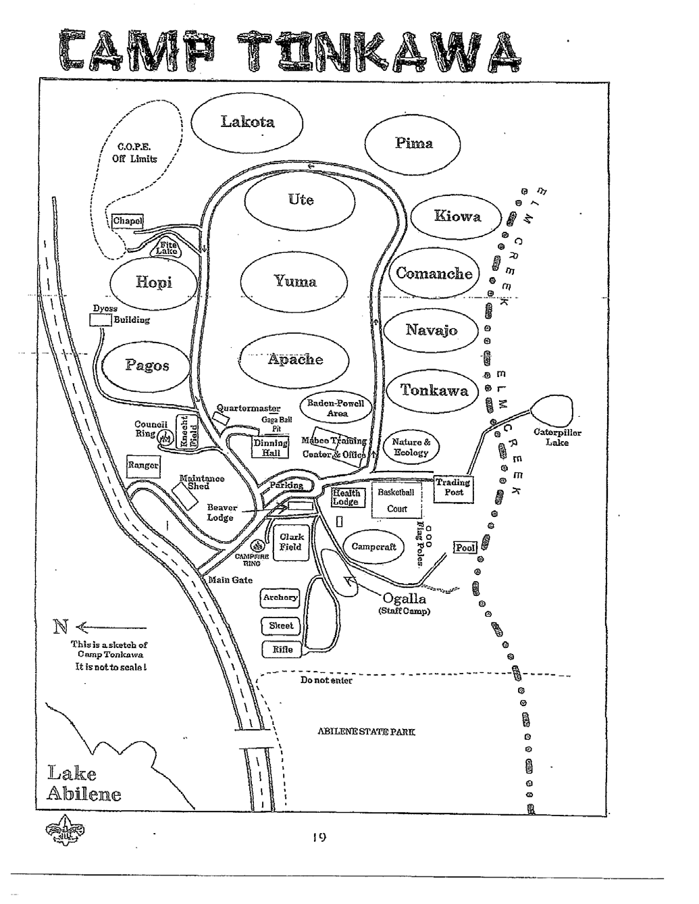

RESIDENT CAMP
YOUTH SPECIAL NEEDS REQUEST

REQUEST FOR PHYSICAL ARRANGEMENTS ASSISTANCE
****INCLUDES SPECIAL DIETARY REQUESTS****
MUST BE COMPLETED BY MAY 25, 2018
Please Print or Type

Pack Number: ________ District:

Unit Leader Making Request:__________________________________________
Phone #:(_______) ____________________

Request made for (Name of Person): ________
Age: ______________
Type of Physical Arrangement, Assistance Requested or Special Dietary Request:

FOR COUNCIL USE ONLY

Date Filed with Council Office: ____________Copy to Camp on: _____________
Copy to Dining Hall Coordinator :_________________________________

WEBELOS ONLY RESIDENT CAMP REGISTRATION FORM

June 17-21

Webelos Leaders MUST register campers as a group. Individual campers may not submit their paperwork to the office. Each Den must have one adult leader for each 4 campers. The maximum size of each den is 12 Scouts.

T-Shirt sizes: Youth Large (14-16), Adult Small, Medium, Large, X-large, XX-Large, XXX-Large. XX and XXX are an additional fee of $3.00 each.

Pack # _____________________

Number of Adults | ______ x $ 80.00 = $ ________________
Number of Partial Week Adult | ______ x $ 30.00 = $ ________________
Number of Webelos | ______ x $ 125.00 = $ ________________
Number of T-Shirts | ______ x $ 12.00 = $ ________________
Number of XXL or XXXL | ______ x $ 15.00 = $ ________________
Late Fees if after May 25 | ______ x $ 50.00 = $ ________________
Total Fees Due | $ ________________

SEND TO: TEXAS TRAILS COUNCIL, 3811 N. 1st ST., ABILENE, TX 79603

Adults Name | Position | T-Shirt Size | Phone Number | Fees Paid

Youth Name | Webelos 1 or 2 | T-Shirt Size | Phone Number | Fees Paid
1.
2.
3.
4.
5.
6.
7.
8.
9.
10.
11.
12.

CUB SCOUT RESIDENT CAMP REGISTRATION FORM

June 24-28

Leaders MUST register campers as a group. Individual campers may not submit their paperwork to the office. Each Den must have one adult leader for each 4 campers. The maximum size of each den is 12 Scouts.

T-Shirt sizes: Youth Large (14-16), Adult Small, Medium, Large, X-large, XX-Large, XXX-Large. XX and XXX are an additional fee of $3.00 each.

Pack # _____________________

Number of Adults | ______ x $ 80.00 = $ ________________
Number of Partial Week Adult | ______ x $ 30.00 = $ ________________
Number of Scouts | ______ x $ 125.00 = $ ________________
Number of T-Shirts | ______ x $ 12.00 = $ ________________
Number of XXL or XXXL | ______ x $ 15.00 = $ ________________
Late Fees if after May 25 | ______ x $ 50.00 = $ ________________
Total Fees Due | $ ________________

SEND TO: TEXAS TRAILS COUNCIL, 3811 N. 1st ST., ABILENE, TX 79603

Adults Name | Position | T-Shirt Size | Phone Number | Fees Paid

Youth Name | T/W/B/Webelo | T-Shirt Size | Phone Number | Fees Paid
1.
2.
3.
4.
5.
6.
7.
8.
9.
10.
11.
12.

NOTES:

