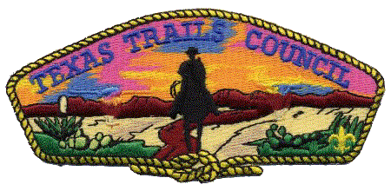
Boy Scouts of America
Texas Trails Council
requests the honor of your presence at the

2019 Distinguished Citizen Award Dinner
Honoring

Lee and Rae Ann Hamilton

Tuesday, March 19, 2019
Featured Guest Speaker: Rex Tillerson
Dinner 7:00 p.m.
Abilene Convention Center Exhibit Hall
1100 N 6th St, Abilene, TX 79601

Eagle Scout $10,000 Two tables of 8 with recognition
Life Scout $5,000 One table of 8 with recognition
Star Scout $2,500 One table of 8 with recognition
1st Class Scout $1,250 One table of 8 with recognition
Tickets $150 One ticket, General seating
All table sponsors and their guests at $2,500 and above (Star Scout Level and above) are invited to attend a private reception with the Honorees and Guest Speaker before the dinner at 6:00 p.m. in the Convention Center upstairs conference room.

_____ Enclosed is my check for $_________ for _________ table / dinner reservations.

_____ I regret I will not be able to attend but enclosed is my contribution of $_________to the Boy Scouts of America, Texas Trails Council in honor of Lee and Rae Ann Hamilton.
Name or Business: ___________________________________________________________________
Address: ___________________________________________________________________________
Phone: _________________ Email: ____________________________________________________

All table sponsors and honorariums $1,000 and above will be listed on the invitation & program, unless requested otherwise.
How name should be listed in invitation/program: _______________________________________________

Make checks payable to: Texas Trails Council
3811 North 1st
Abilene, TX 79603

For additional information: Cindy Webb: ciwebb@bsamail.org or call 325-677-2688

Boy Scouts of America is a 501(c)3 organization. Contributions are tax-deductible.
*Money raised by this event will support the operating needs of Texas Trails Council.

