Ringling Park - Eastland, TX

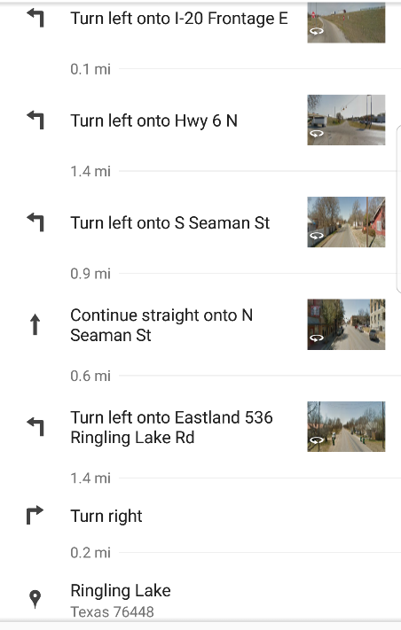

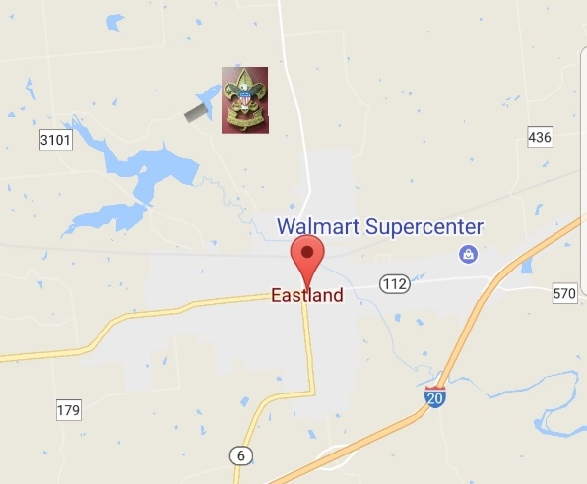

Ringling Lake and Park were originally built as a water stop for the Eastland, Wichita Falls & Gulf Railroad (aka the Ringling Railroad) by investors that included H. P. Brelsford, Earl Conner, Breckenridge Stephens Walker, C.U. Connellee and others. The railroad was to extend from May in Brown County to Newcastle in Young County. The line began in 1918 and was financed by John Ringling, of circus fame and was known for a time as the Ringling, Eastern and Gulf Railway. Unfortunately, the circus never made stops at the lake. The line was abandoned in 1944 and the property was deeded as a permanent park to the City of Eastland.

