Parent Guide to
Haunted Forest
October 17 – 19, 2025
Mysterious Creatures
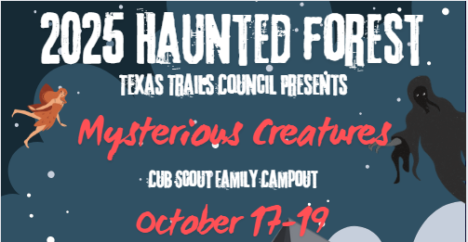

Come join us for fun at Camp Tonkawa
Located at 4117 FM 89, Tuscola, Texas

For your information
Youth Protection Training: Cub Scout – Overnight Exception
Cub Scout parents or legal guardians taking part in an overnight Cub Scout program with their own child or legal ward are not required to register as leaders. All adults must review the “How to Protect your Children from Child Abuse: A Parent’s Guide” that can be found in the front of each Cub Scout Handbook. In addition, the parent or legal guardian must be accompanied by a registered leader at any time they are with youth members other than their own child/ward. All other overnight adults must be currently registered in an adult fee required position.
Annual Health and Medical Record: Forms A and B
For any and all Scouting activities, all participants must complete Part A and Part B (both pages). “All participants” includes parents, guardians, siblings, youth, staff, and unit leaders. Though Part C is only required for participation in events lasting longer than 72 hours, all Boy Scouts of America participants are encouraged to complete this pre-participation physical during an annual exam performed by a licensed health-care provider.
Release and Indemnity/Hold-Harmless agreement
All adults must complete the agreement (attached in this parent’s guide). Your children may be listed on one of the parent’s form. It must be completed and ready to turn in when you check in to camp.
Registration for Haunted Forest
Can be done online by going to www.texastrailsbsa.org and clicking on the Haunted Forest button in the calendar of events. You may also sign up in person at the Scout office using the attached registration form. If you want to register as a unit, please contact the Scout office at 325-677-2688.
Friday Evening Check-in
Check-in will be from 5:00 pm to 8:00 pm. This is where you will pick up your schedule, map, arm bands and event patch. You will not be allowed to participate unless you are wearing an armband. You will be allowed to set up your campsite starting at 5:00 pm. There will be someone available to direct you to your assigned campsite. There will be NO campsite setup permitted after 9:00 pm on Friday night, and no one will be allowed to enter Camp Tonkawa after 10:00 pm. Participants will be allowed 15 minutes to drop off their equipment at their campsite, then park across the street. Please do not set up camp until your vehicle has been moved.
Saturday Check-in
Check-in will resume on Saturday from 8:00 am to 2:00 pm.

Saturday Evening Carnival and Haunted Trail
For the safety of all campers, driving on the campsite loop will be suspended from 5:00 pm to 10:00 pm. No one will be permitted to drive through the campsite loop during this time as it will directly interfere with evening activities. Shuttle services will be available at this time. Should you plan to leave Saturday evening, please pack camp and load your vehicle before 5:00 pm.
Trading Post and Snack Bar
The Trading Post will be open Friday evening from 5:00 pm to 9:00 pm. They will be selling hamburgers, hotdogs, nachos, and personal pizzas. It will also be open throughout Saturday, except for scheduled mealtimes.
Meals
Meals will not be provided for Friday evening. Breakfast, lunch, and dinner on Saturday will be provided. Sunday breakfast will be a simple grab and go that can be picked up at the dining hall. A salad bar will be provided for Saturday meals.
Tentative Menu (subject to change)
Saturday Breakfast | Saturday Lunch | Saturday Dinner | Sunday Breakfast
Mountain Man Casserole | Finger Hot Dogs | Chicken Alfredo | Grab & Go
Please contact the Scout Office if you have dietary restrictions.
T-Shirts
Haunted Forest T-Shirts are available for purchase. They come in Youth sizes Small through Large and Adult sizes Small to 4XL. This preorder item must be submitted by October 3, 2025. There will be a few available for purchase at the Trading Post on a first-come basis.
Shuttles
Shuttles will be available to take you to the parking lot across the street. Please do not cross the highway on foot. Please wait for a shuttle at the designated shuttle stops on the map. Shuttle run times are listed on the schedule.
ADA Accommodations
Please contact the Scout Office prior to the campout should you need an ADA accommodation.
Cost:
- $30.00 per Participant if paid by October 1st
- $120.00 per Family of 5 or more if paid by October 1st
- $35.00 per Participant after October 1st
- $150.00 per Family of 5 or more after October 1st
- $45.00 If registering the day of the event per person. No discount for families.
- Children 4 years old and younger are free.
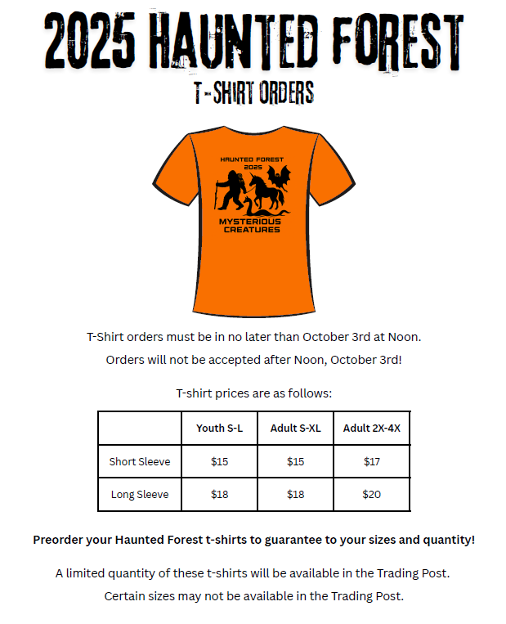

Schedule*
Friday
05:00pm – 08:00pm Check-in
05:00pm – 09:00pm Campsite setup
08:00pm – 09:00pm Welcome Campfire (Campfire Ring)
09:00pm All-Volunteer Meeting (immediately after campfire in Dining Hall)
10:00pm All quiet in Camp
05:00pm – 10:00pm Shuttle Service Availability

Saturday
06:30am – 08:15am Breakfast
08:15am – 08:30am Flags
08:30am – 11:25am Rotating Morning Activities
11:30am – 01:25pm Lunch
01:30pm – 04:25pm Rotating Afternoon Activities
04:30pm – 06:25pm Dinner
06:30pm – 09:00pm Carnival Activities
08:00pm – 10:00pm The Haunted Trail
06:30pm – 10:00pm Movie in the Dining Hall (Hotel Transylvania)
11:00pm All quiet in Camp
07:00am – 10:00pm Shuttle Service Availability

Sunday
08:00am – 09:30am Grab and Go Breakfast
08:30am – 09:00am Closing Ceremony and Awards
09:00am – 09:30am Scout’s Own Service (Pavilion)
09:30am – 10:55am Break Camp, Cleanup and Checkout
11:00am All Campers Cleared Out
07:00am – 11:00am Shuttle Service Availability

*Tentative schedule subject to change

Fun Extras
Pumpkin Carving Contest
Bring a pre-carved pumpkin. A table will be set up outside the dining hall.
Campsite Decorating Contest
Get with the other families in your Pack and decorate for the theme.
Pack Scout Spirit Award
Be the Pack with the most spirit; create a cheer and sing throughout camp. Show your Scout Spirit.
Best Themed Costume – Cub Scout
Most Unique Costume – Cub Scout
Best Themed Costume – Scouts BSA
Best Themed Costume – Adult Leader
Please be sure to wear your costume at lunch and dinner so the judges can see you!
All winners will be announced Sunday morning.
What to Bring
Tent (and stakes) Towels
Hammer or mallet Rain gear
Ground cloth/tarp Jackets
Dustpan & brush and or broom Hats
Sleeping bags Sunscreen
Sleeping pads Small day pack
Pillow Medications
Headlamps or flashlights (and extra batteries) Bug spray or bug bands
Lantern (and mantles and fuel/batteries if needed) Disinfectant wipes
Camp chairs Hand Sanitizer
Change of clothes Cub Scout 6 Essentials
Extra pair of shoes
Sleep wear
Personal hygiene products (showers are available)
Shower shoes
Small first aid kit (Health Lodge will be open if needed)

Rules for Safety and Conduct
- Speed limit is 10 MPH on ALL camp roads.
- Park only in designated areas. No parking of personal vehicles in camping areas.
- No passengers can ride in the bed of a pick-up truck.
- DO NOT LITTER. Please dispose of trash properly.
- Bag all trash – Do not stack loose rubbish on top of the bin. Place tied trash bags at the entrance to the campsite for pickup.
- Do not place embers or charcoal into the trash bins. Use appropriate means to extinguish fires.
- Swimming Pool, COPE Area, and Tonkawa Tower are OFF-LIMITS.
- Possession or consumption of alcoholic beverages is NOT permitted.
- Possession or consumption of illegal drugs is NOT permitted.
- Fireworks, and Personal Firearms are NOT permitted.
- Pets, except for registered service animals, are NOT permitted.
- Camp Tonkawa is a smoke free property. Tobacco products (cigarettes, cigars, vaping devices) are not allowed in camping areas or program areas. Please NO smoking or vaping during programs or Campfires. Be courteous to your fellow scouts!

Map of Camp Tonkawa
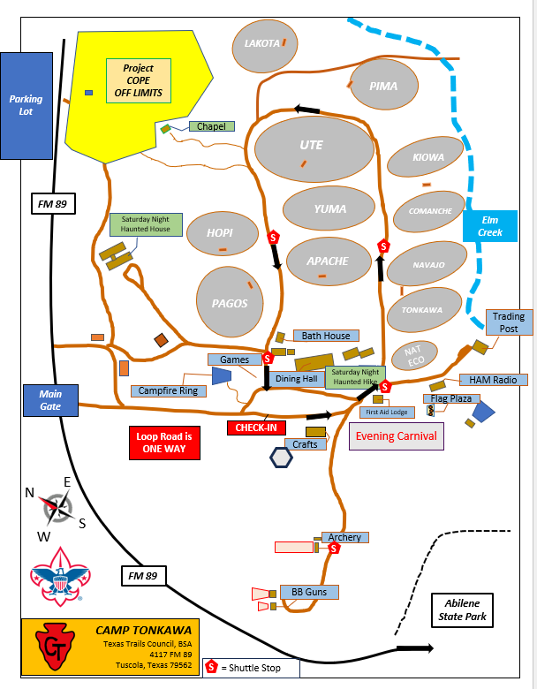

An updated map will be provided in your check-in packet.

Texas Trails Council, BSA
3811 North 1st Street
Abilene, Texas 79603
325-677-2688

RELEASE AND INDEMNITY/HOLD-HARMLESS AGREEMENT

I understand the use of facilities owned by Texas Trails Council, BSA involves a certain degree of risk that could result in injury or death. In consideration of the benefits to be derived and after carefully considering the risk involved and in view of the fact that the Boy Scouts of America is a not-for-profit organization:

RELEASE AND INDEMNIFICATION

I hereby release and waive any and all claims that I may have against Boy Scouts of America, Texas Trails Council, BSA and their employees, agents, representatives, or volunteers arising from use of their facilities. I AGREE TO FULLY INDEMNIFY AND HOLD HARMLESS BOY SCOUTS OF AMERICA, TEXAS TRAILS COUNCIL, BSA, AND THEIR EMPLOYEES, AGENTS, REPRESENTATIVES, AND VOLUNTEERS FROM ANY AND ALL CLAIMS ARISING FROM USE OF THEIR FACILITIES. THIS INDEMNIFICATION EXPRESSLY INCLUDES ANY CLAIMS ARISING OUT OF THE BOY SCOUTS OF AMERICA, TEXAS TRAILS COUNCIL, BSA’S OWN NEGLIGENCE OR FAULT OR THAT OF THEIR EMPLOYEES, AGENTS, REPRESENTATIVES, OR VOLUNTEERS. I AGREE THAT THE INDEMNIFICATION INCLUDES THE AMOUNT OF THE CLAIMS, THE EXPENSES OF DEFENDING AGAINST THE CLAIMS, COURT COSTS, AND ATTORNEYS’ FEES.

____________________________________________ ________________________
Adult Printed Name Date

____________________________________________ ________________________
Signature (if over 18 years of age) Telephone Number

List of your dependent children under 18 years of age.

First and Last Name of Dependent Child Relationship

____________________________________________ ________________________

____________________________________________ ________________________

____________________________________________ ________________________

____________________________________________ ________________________

____________________________________________ ________________________

____________________________________________ ________________________

